HOTELAND RESTAURANTASSOCIATION OF WESTERN INDIA
FSSAI – FoSTaC Website - STEPS TO FOLLOW FOR REGISTRATION.
STEP 01: To go to the home page of the portal or open the portal, please click on the following link:
https://fostac.fssai.gov.in/Fssai_E-Learning_System/index.jsp
STEP 02: Register on the FSSAI – FoSTaC Website as a Trainee,
Step 03: System will re-direct to a new screen , click on “Click here to Register button” given on the screen.
Step 04: System will show 1st part of the form for Trainee Registration process, which includes AADHAR NUMBER & PAN NUMBER TO BE FILLED AS MANDATORY.
( IF AADHAR NUMBER AND PAN NUMBER IS NOT VALID OR WRONG, SYSTEM WILL NOT LET USER COMPLETE REGISTRATION PROCESS ).
After filling complete information given in form, click on “Verify” button to proceed further.
On successful Verification, System will redirect to next Registration Page for filling complete Trainee Details.
Registration form is divided into different parts as:
- Personal Information like name, Father’s name, gender etc as mentioned in above image.
- Correspondence Address, fill complete address details with pin code and mobile number.
- Permanent Address, if permanent address is different from correspondence address; then fill the details else mark the check box as tick for same permanent and correspondence address.
- Business Details, trainee can select its business details, but if he/she is not into business then can select option as “not in business”, then related details to business will get hide.
- If trainee is in some business then trainee should fill business address as well, system is also giving option as same business address as correspondence address. For this need to mark the check box.
Once Registration Process will be completed, acknowledgment mail will be sent to the mentioned email Id with system generated User Id and password to Login into the system. Same User id and Password will be shared on the screen as well.
(KINDLY MAINTAIN A RECORD OF THE USER ID & PASSWORD).
On clicking on Login button, system will re-direct to login page for trainee as:
To login into portal, trainee will input User Id and password mentioned while registration process and then Captcha mentioned on the screen.
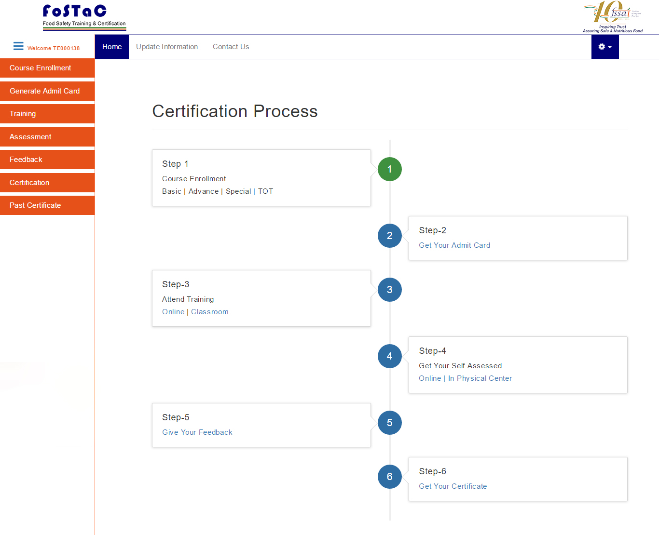
After filling the details, click on Submit button then system will redirect to home page of trainee.
Once Trainee has successfully login into Portal, system will allow Trainee to fulfil these mentioned activities:
- Complete training
- Update Registration Details
Check the status of training of trainee
STEP 05: Course Enrolment- Trainees can enrol themselves for the specific course for example BASIC, ADVANCED, SPECIAL and TOT categories. Course enrolment procedure will as:
- Click on course enrolment ---> select course type from drop down
- Select course code from drop down
- Click on show details- system will show the training calendar available for the selected course at various training centres.
- Select the training calendar and click on “Enrol” button. (at the same time trainee, can enrol to one course only)
- Click ok for the notification message on the screen. System will show unique roll number id for the student.
STEP 06: Get your Admit Card- Trainee will get the admit card after enrolment of the course, for this click on “Generate Admit Card”.
Trainee can download and print the admit card and carry while attending classroom training.
STEP 07: Attend Training-There will be CLASSROOM TRAINING:
- Classroom: for CLASSROOM TRAINING, trainee will attend training at classroom and course material will be available at the Training Centre. System will show notification message on screen.
STEP 08: Get Your Certification- Trainee will get Certificate after the successful completion of the training process and clearing the assessment.
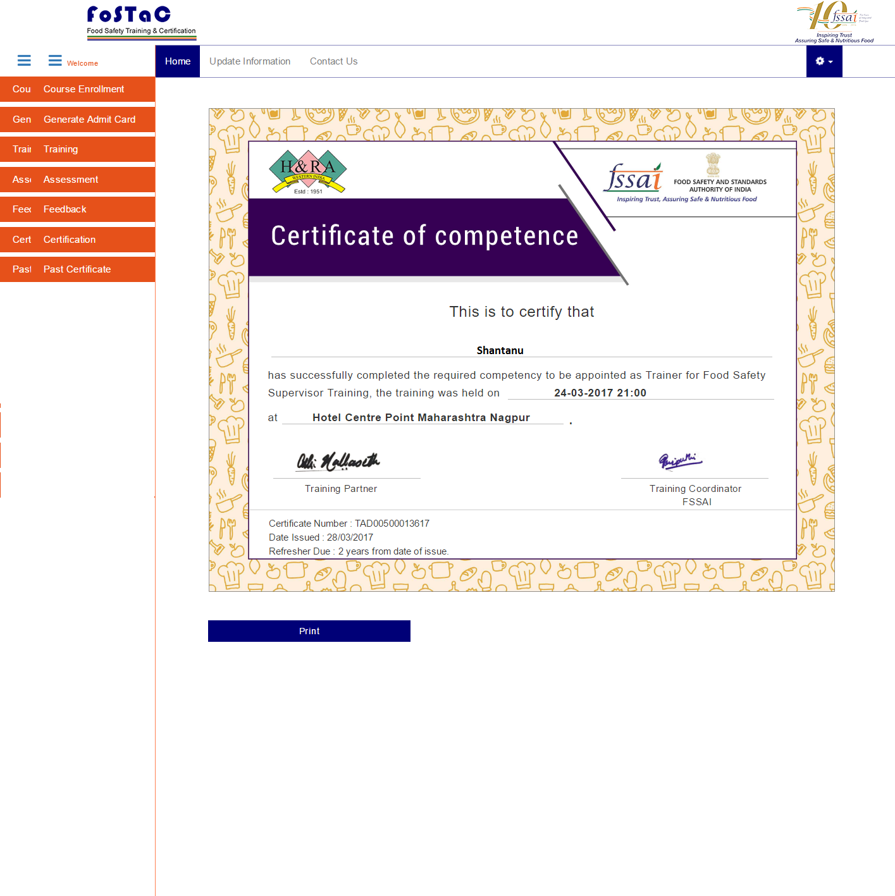
Trainee will click on certificate button to get certificate. To print certificate click on Print button. To download past certificates, trainee will click on Past certificate button and select / input unique id for the completed courses. On click show details system will show the certificate for the past training and trainee will be able to download it as per above procedure mentioned.

