FoSTaC
Food Safety Training and Certification
The main purpose of this Portal to provide all the related information at one platform about this course.
- Various users like Trainee, Trainer, Assessor can Register themselves through this Portal
- All Required information about the courses going to be held by the Organization, for example Calendar, Course content, Assessment schedule etc.
- Different Training Centres at different Zone, State or City with all related information
- Online Training with their schedule and content
Detail functionality of Fostac Portal for Trainee User is mentioned as below:
To go to home page of portal or open portal please click on following link:
https://fostac.fssai.gov.in/Fssai_E-Learning_System/index.jsp
On click on above link system will show below mentioned screen.
To proceed further Trainee must follow the given below steps:
First time user:
- Click on trainee link to register themselves, details of the registration process are explained below under Registration section.
Already Registered User:
- Click on Login button to proceed further with training and other functionalities, details for the training process is explained below under training section.
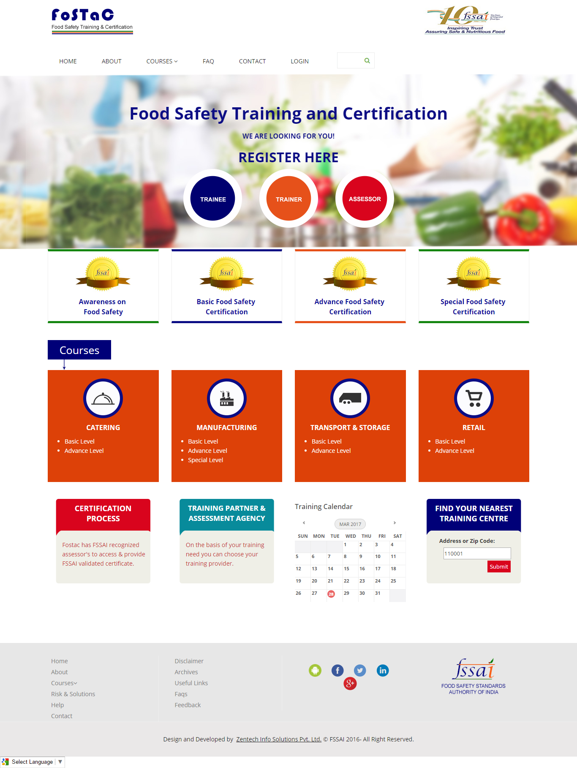

Trainee Registration Process
Step1: Click on Trainee link given on home page
Step2:System will re-direct to below mentioned screen , click on “Click here to Register button” given on the screen.

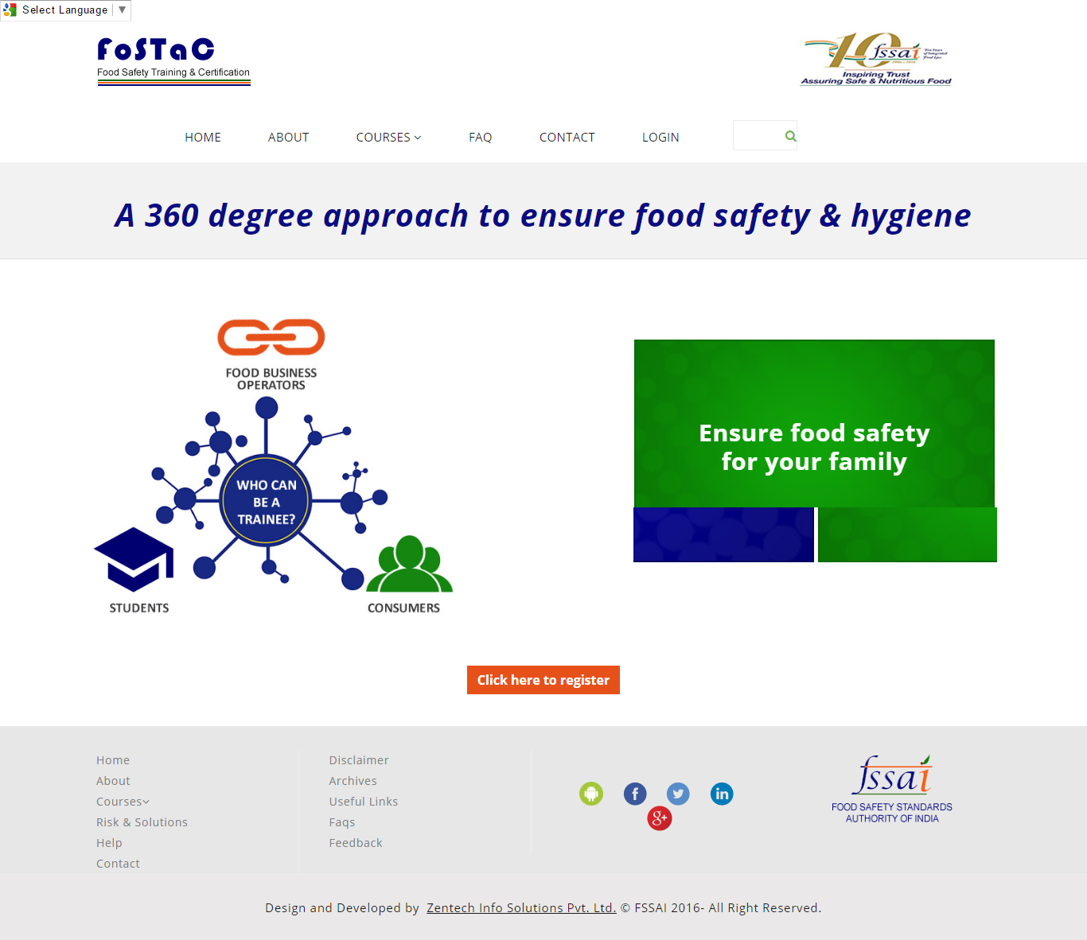
Step 3:System will show 1st part of form for Trainee Registration process, which includes Aadhar number to be filled as mandatory.
If Aadhar number is not valid or wrong, system will not let user complete registration process.
After filling complete information given in form, click on “Verify” button to proceed further.
Trainee Registration Form
Adhar No will be Mandatory for Registration Process
On successful Verification, System will redirect to next Registration Page for filling complete Trainee Details.
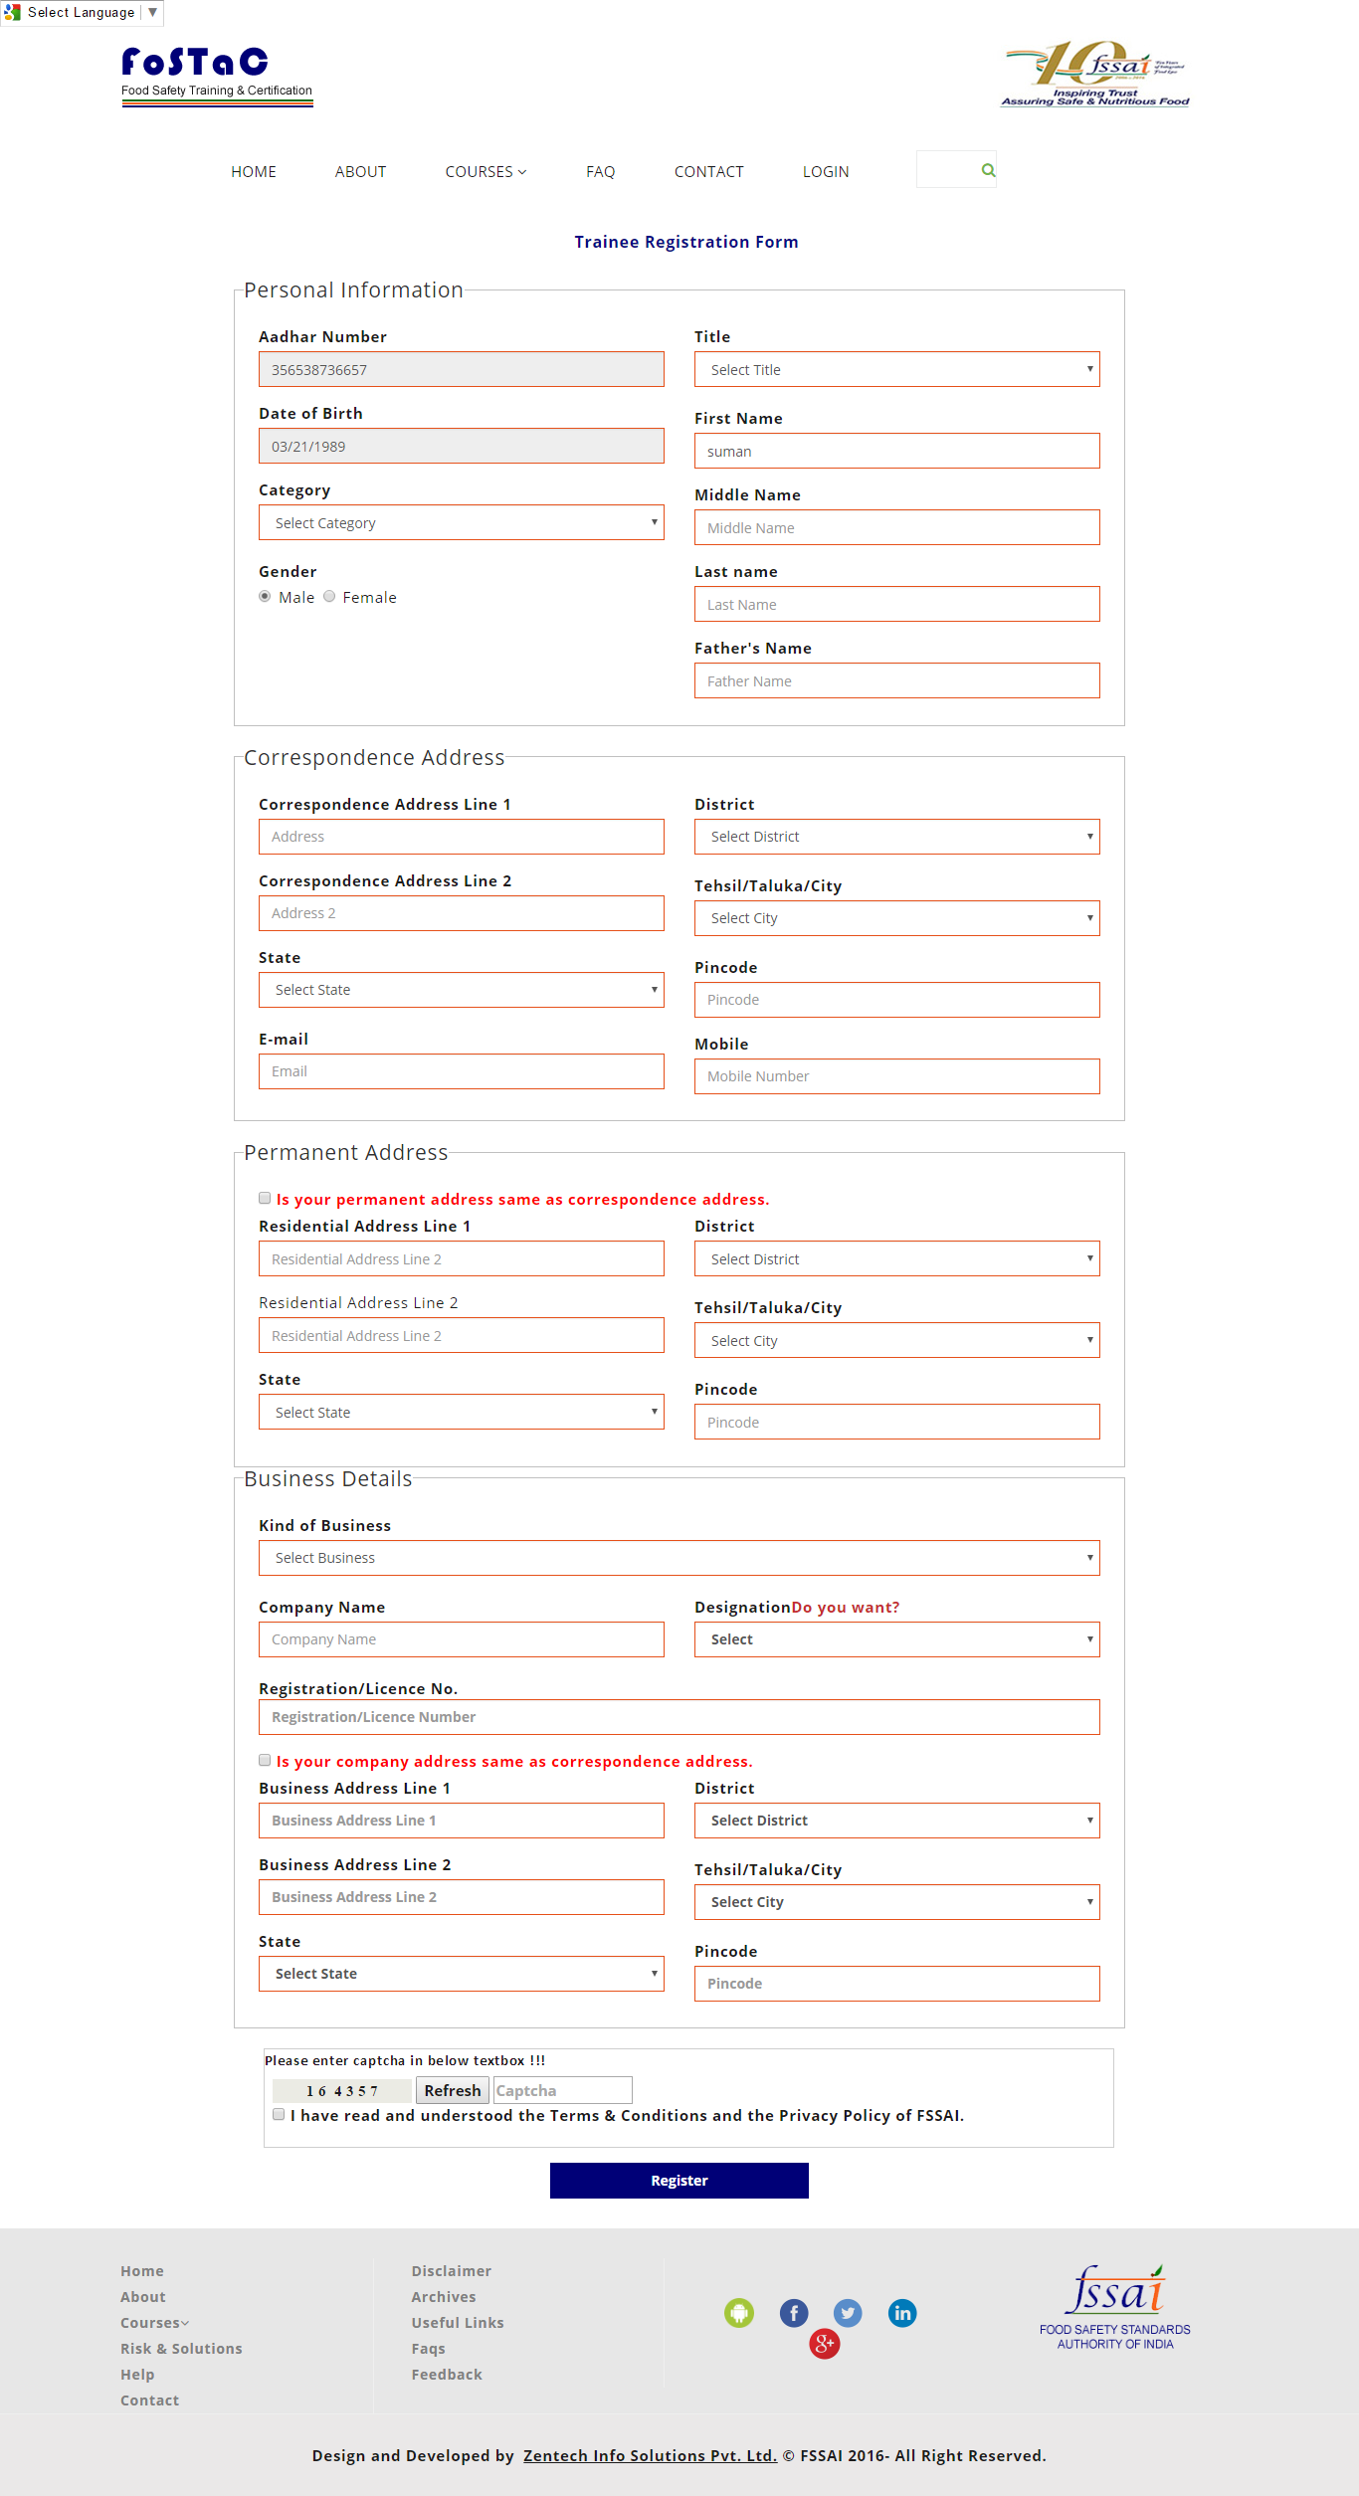
Registration form is divided into different parts as:
- Personal Information like name, Father’s name, gender etc as mentioned in above image.
- Correspondence Address, fill complete address details with pin code and mobile number.
- Permanent Address, if permanent address is different from correspondence address; then fill the details else mark the check box as tick for same permanent and correspondence address.
- Business Details, trainee can select its business details, but if he/she is not into business then can select option as “not in business”, then related details to business will get hide.
- If trainee is in some business then trainee should fill business address as well, system is also giving option as same business address as correspondence address. For this need to mark the check box.
Once Registration Process will be completed, acknowledgment mail will be sent to mentioned email id with system generated userid and password to login into the system. Same User id and Password will be shared on the screen as well.

Trainee Login Process
To login into the system, again trainee should go to home page of FOSTAC website mentioned below.
On click on Login button, system will re-direct to login page for trainee as:
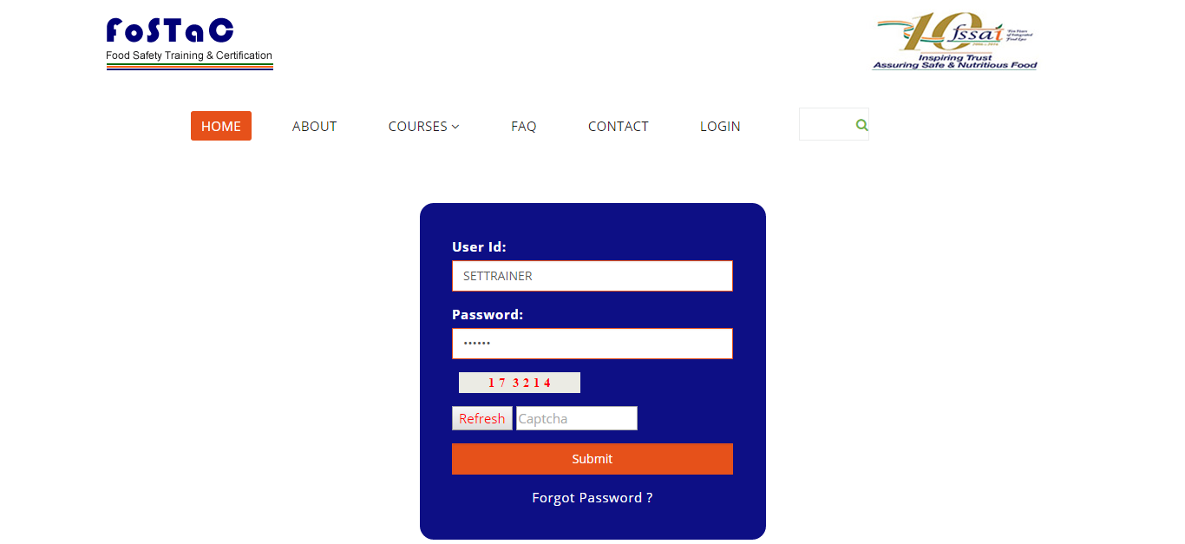
To login into portal, trainee will input userid and password mentioned while registration process and then captcha mentioned on the screen.
After filling the details, click on Submit button then system will redirect to home page of trainee.

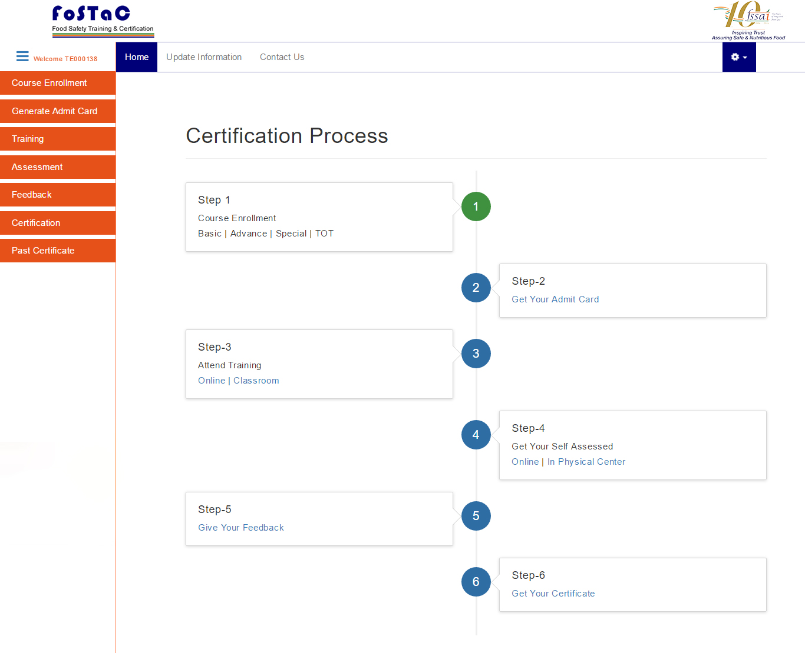

Once Trainee has successfully login into Portal, system will allow Trainee to fulfil these mentioned activities:
- Complete training
- Update Registration Details
- Check the status of training of trainee
Complete description of each step is mentioned as below:
Home Page: Home page for trainee will show the steps trainee has completed/achieved to complete one training. After the completion of training, trainee will be awarded with certificate
Update Information: As mentioned above, on click on this link, system will allow trainee to modify its information and save it, except for the few information like personal details will remain unchanged.
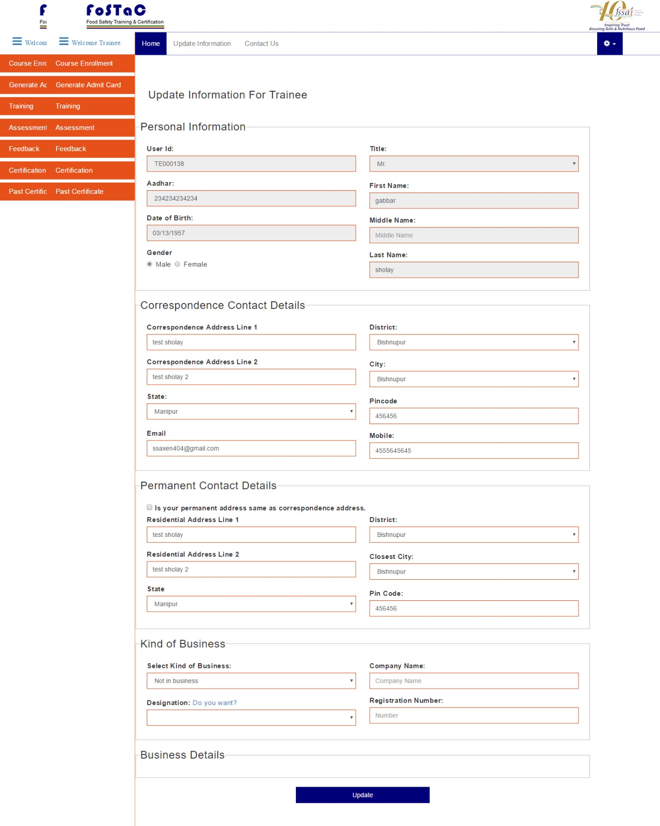

Contact Us: This link is given to send mail to FSSAI authorities for any doubts and queries related to the portal and training.
Just need to type the message/query and click on submit button. Trainee can change its email id if needed for further communication over this screen as well directly.

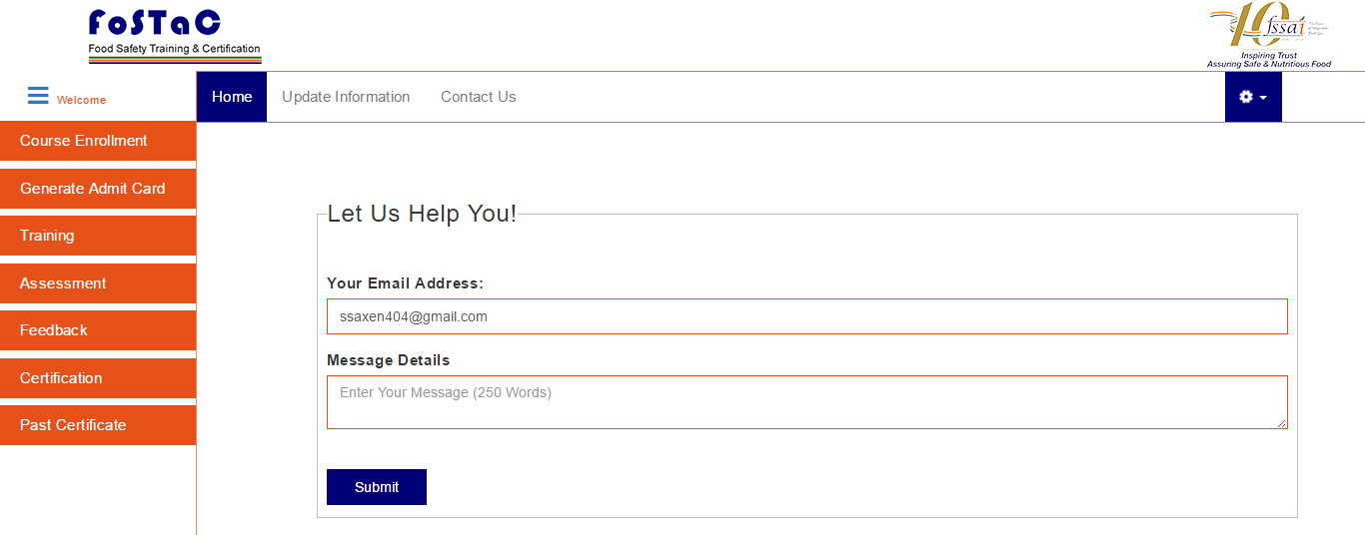
Settings: This option is given for the given purposes
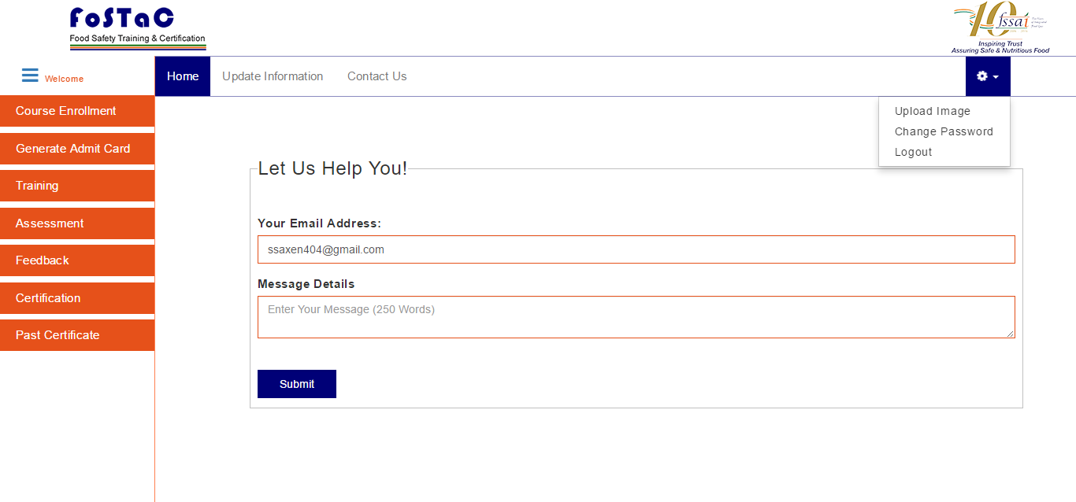
- Upload image: Select the image from your machine and click on upload button to save image in the profile.

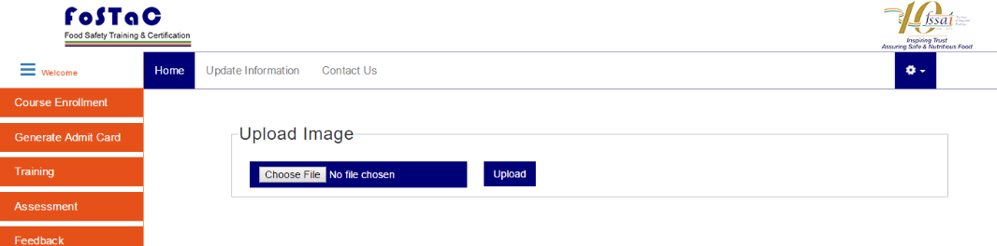

- Change password: To change password, first input the current password and then new password and click on change password button to confirm the changes.

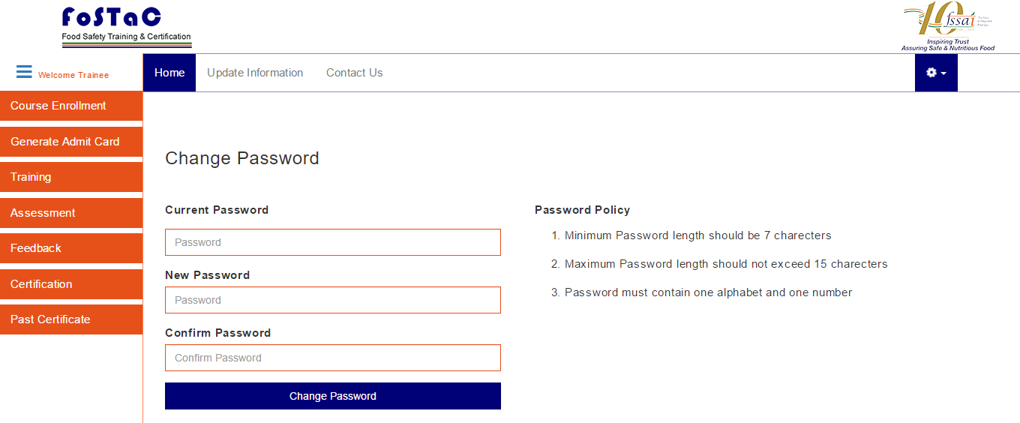

- Logout: Click on Logout button to come out from the trainee screen.

Certification/Training Process for Training
Trainee can enrol for training from this page. Certification Process of Trainee will include steps as follows:
STEP 1: Course Enrolment- Trainees can enrol themselves for the specific course for example BASIC, ADVANCED, SPECIAL and TOT categories. Course enrolment procedure will as:
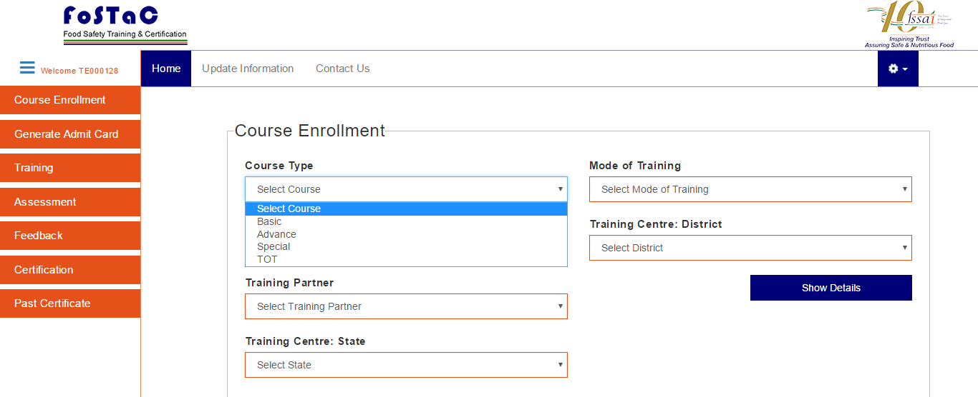

- Click on course enrolment->select course type from drop down
- Select course code from drop down
- Click on show details- system will show the training calendar available for the selected course at various training centres.
- Select the training calendar and click on “Enrol” button. (at the same time trainee, can enrol to one course only)
- Click ok for the notification message on the screen.
- System will show unique roll number id for the student.
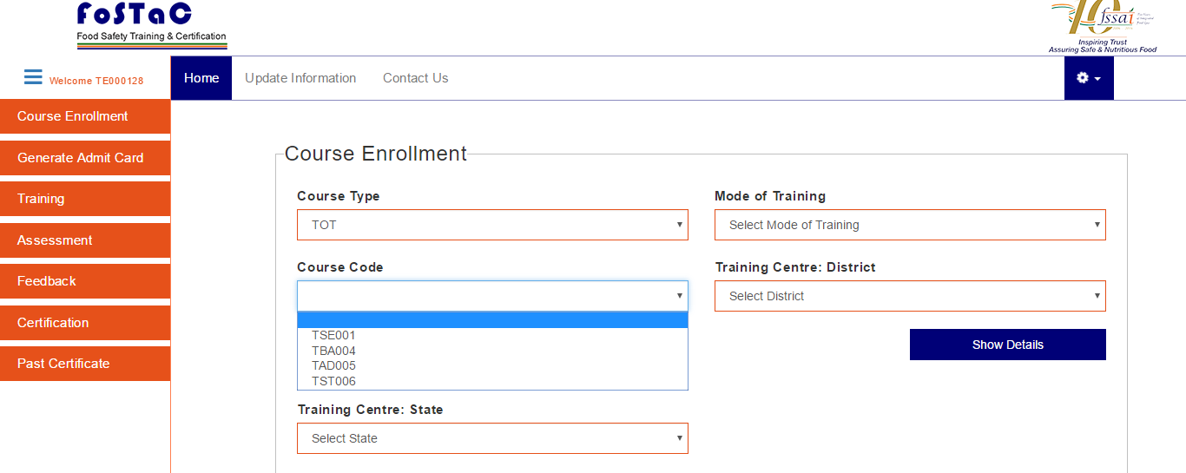

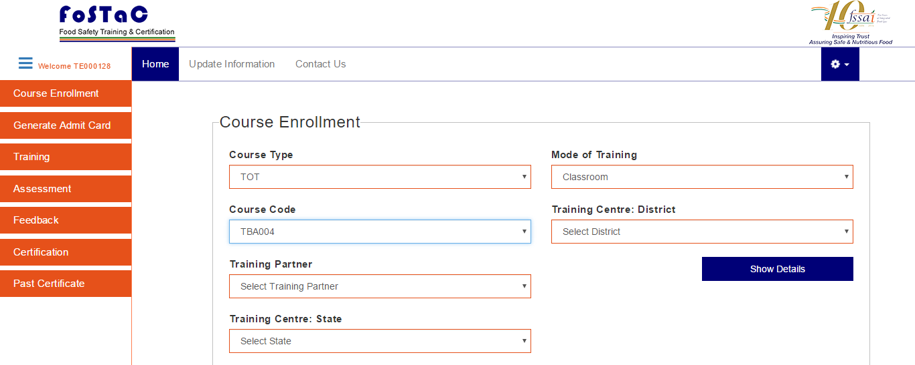

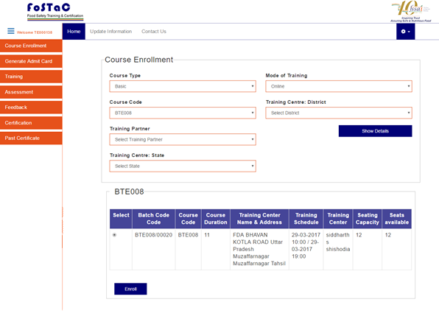
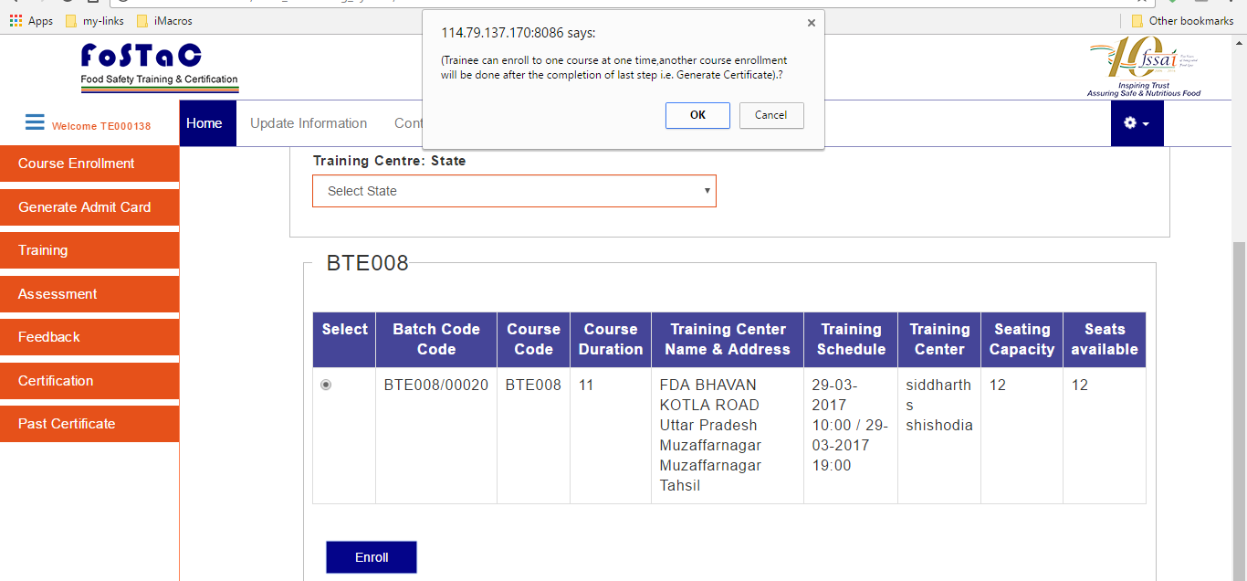

STEP 2: Get your Admit Card- Trainee will get the admit card after enrolment of the course, for this click on “Generate Admit Card”.
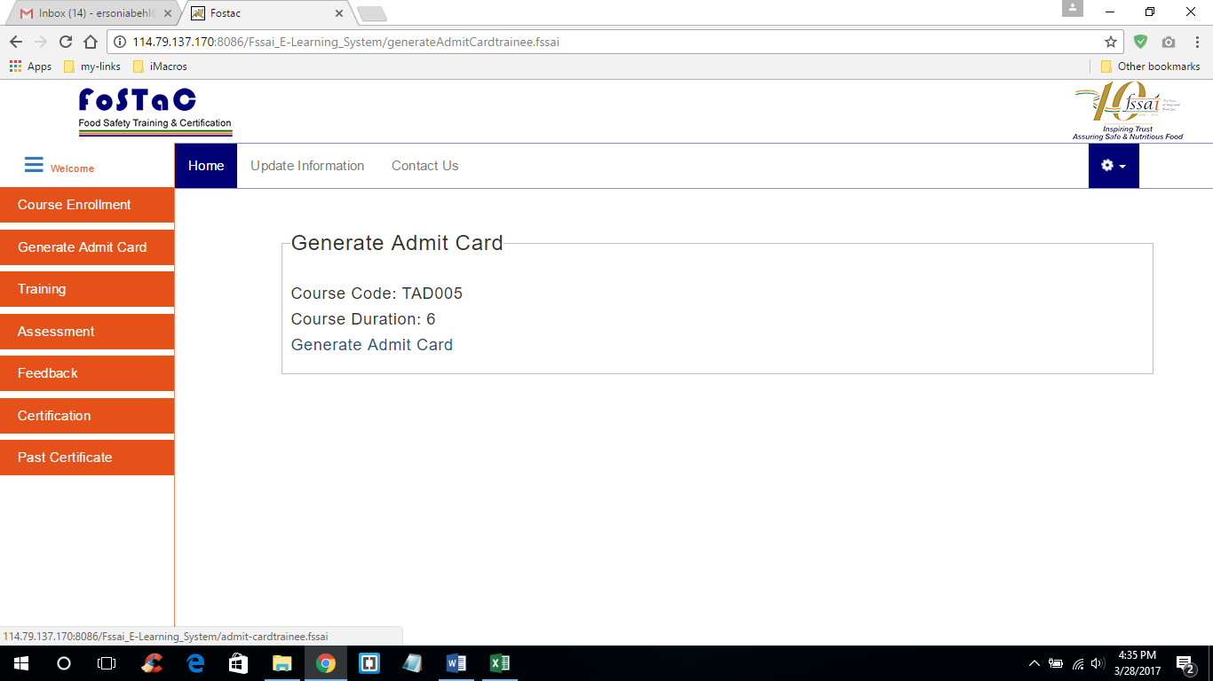

Trainee can download and print the admit card and carry while attending classroom training.
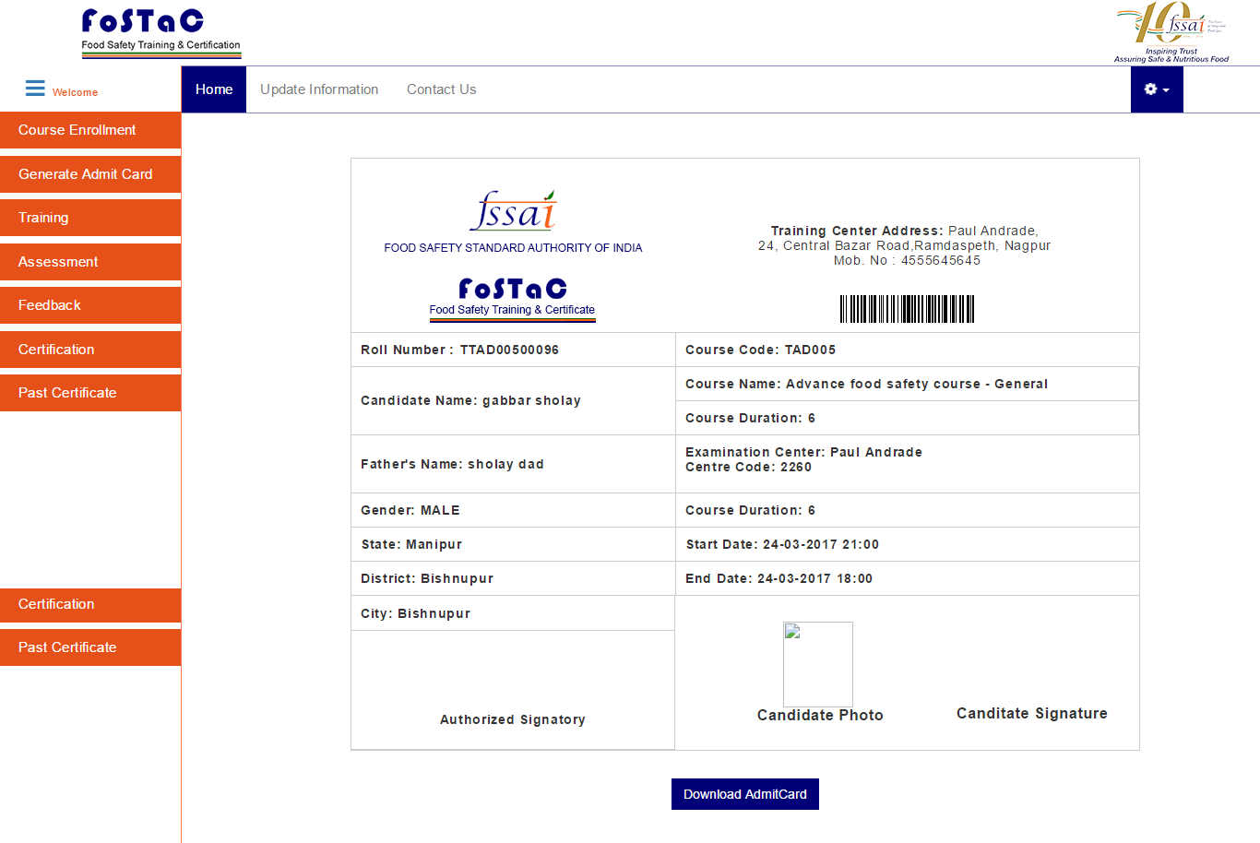
STEP 3: Attend Training-There will be two modes of trainings
- Classroom: for classroom training, trainee will attend training at classroom and course material will available over there. System will show notification message on screen.
- Online: For online, trainee can download or read course material from the portal itself.
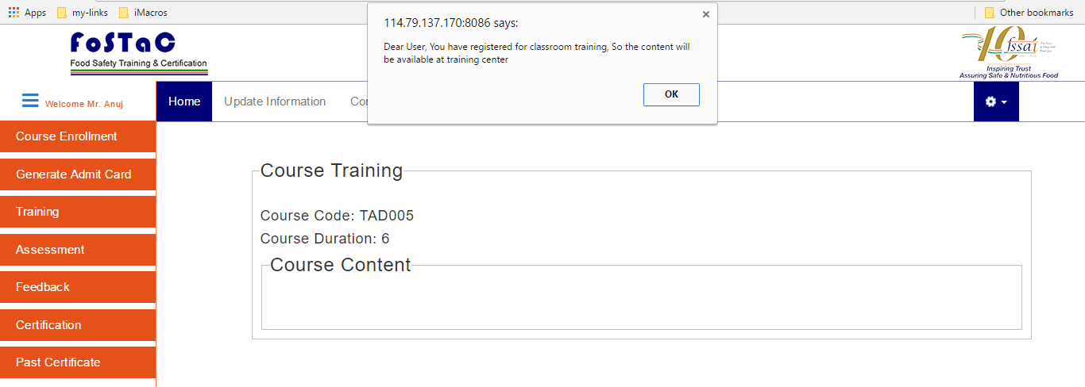
Classroom training

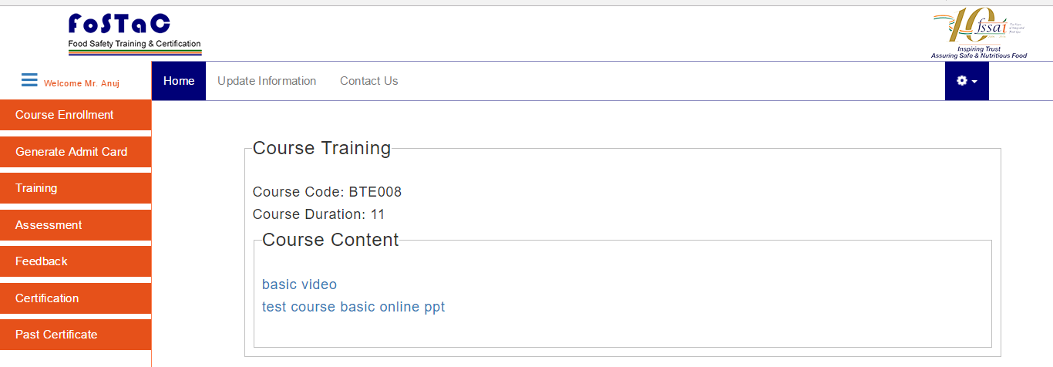
Online training

STEP 4: Get yourself Assessed-Assessment criteria will be again based on the mode of training. For online training assessments, will be done on the portal as shown below. For classroom assessment, assessment will be done in classroom venue by assessor.
When trainee will click on Assessment; System will show notification message in case of classroom mode of training.
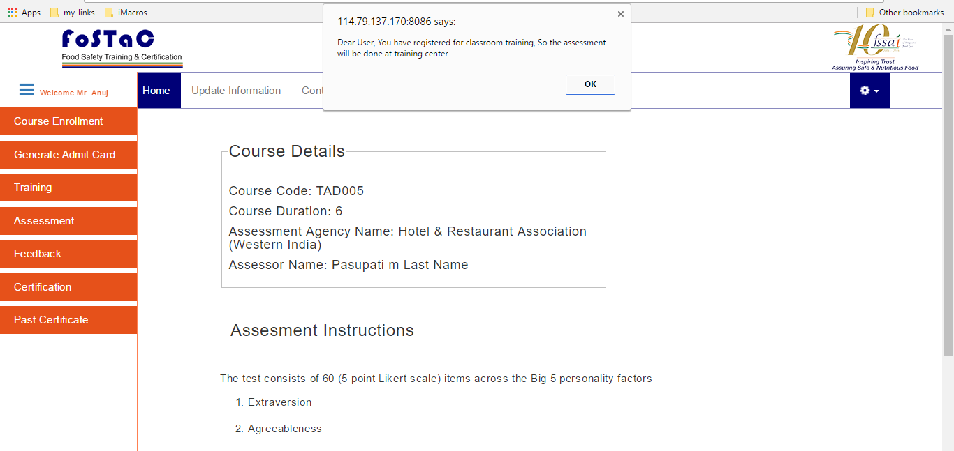
For Online Assessment:
- Click on Assessment
- Click on start assessment, system will redirect to question paper page
- Complete the assessment test and click on submit button, then system will show the result as pass or fail.
- If assessment is cleared , only then trainee will be able to print certificate.
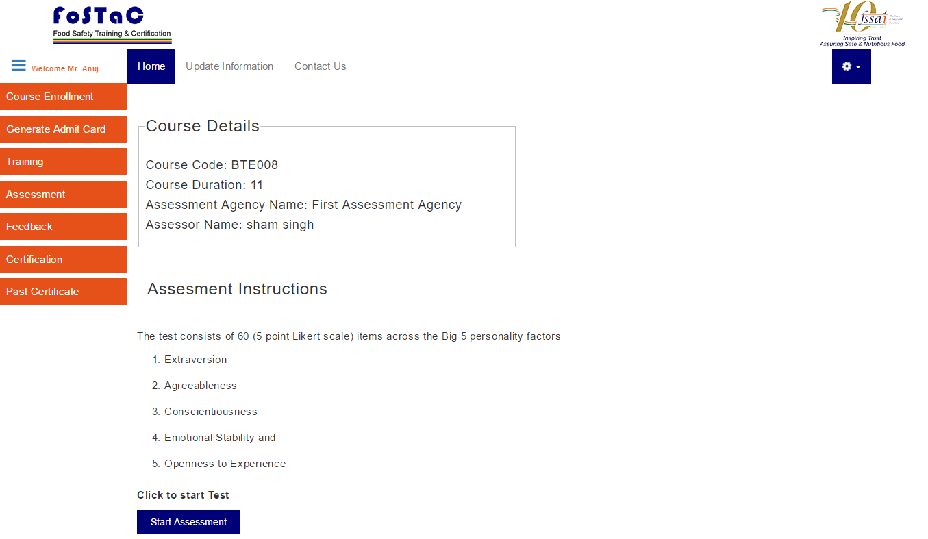
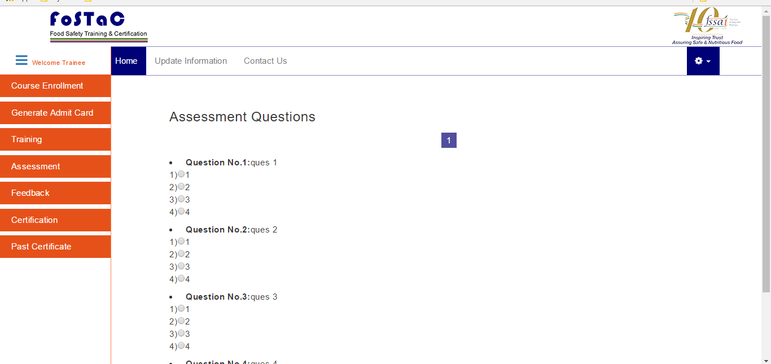

STEP 5: Give Your Feedback- Trainee will give feedback on the Training Centre, Course Contents and Trainer.
Click on Feedback -> give feedback-> click on submit button
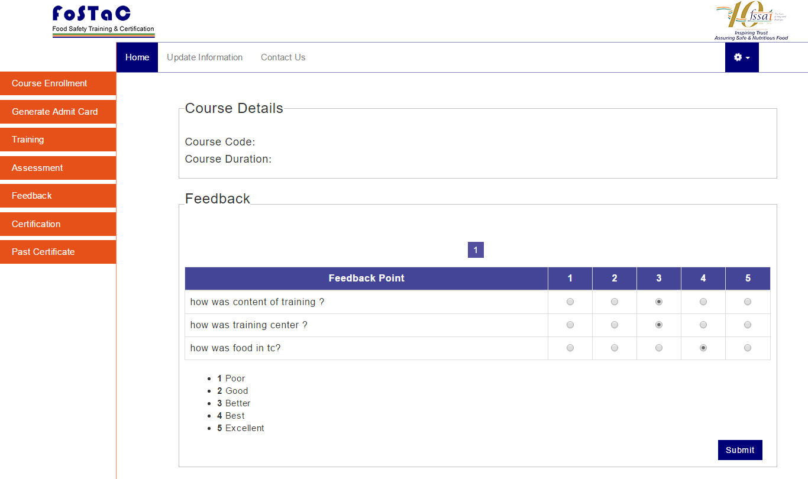

STEP 6: Get Your Certification- Trainee will get Certificate after the successful completion of the trainingprocess and clearing the assessment.
Trainee will click on certificate button to get certificate. To print certificate click on Print button.
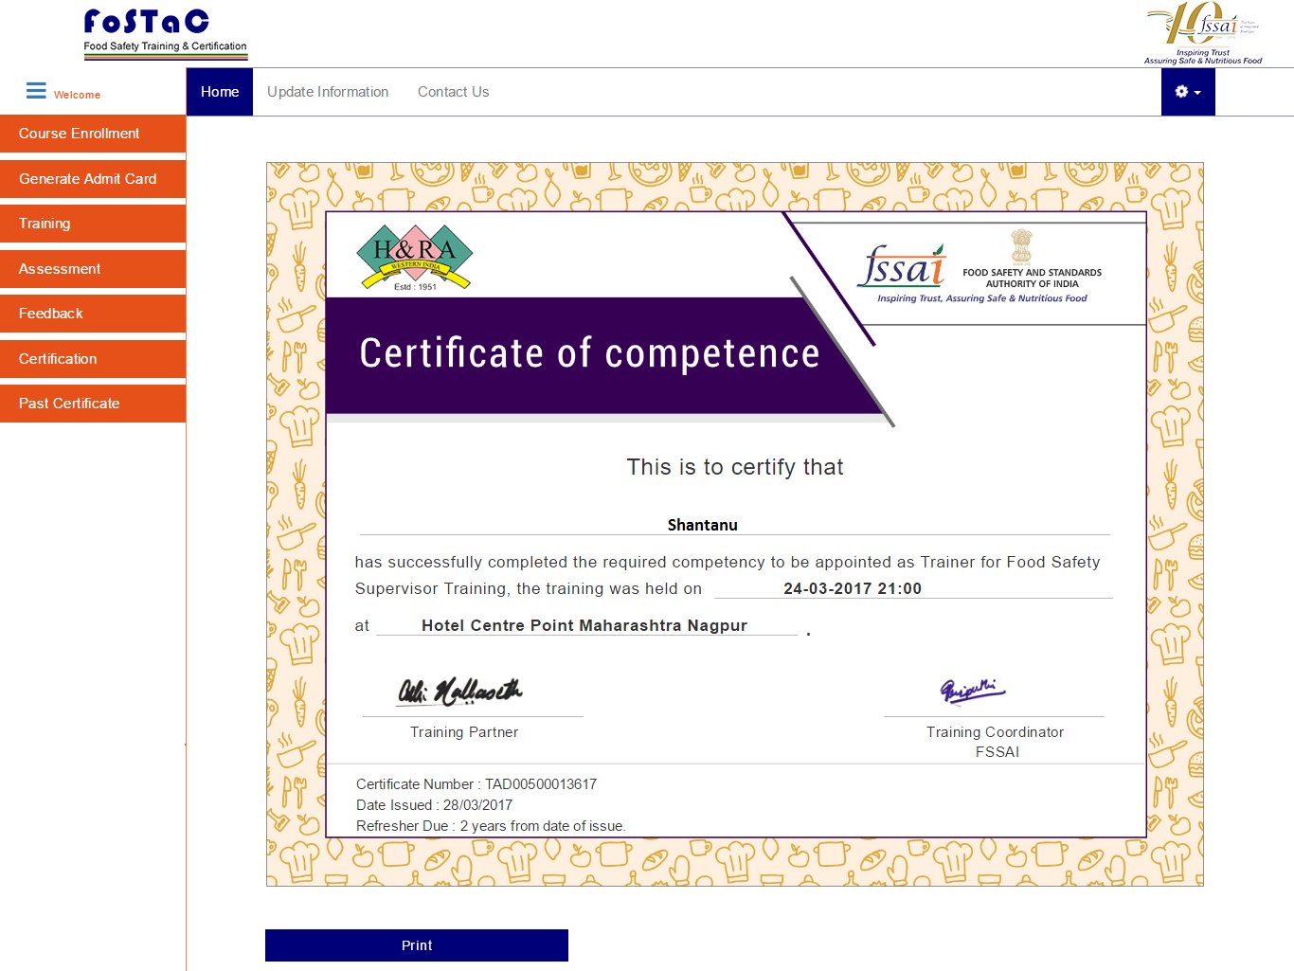
To download past certificates, trainee will click on Past certificate button and select/input unique id for the completed courses. On click show details system will show the certificate for the past training and trainee will be able to download it as per above procedure mentioned.

