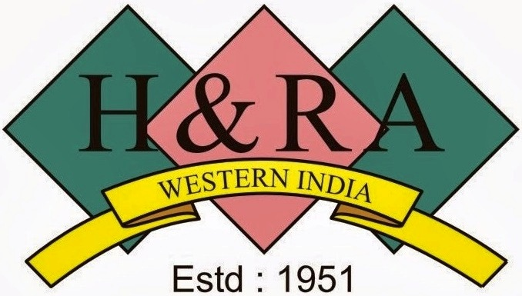

Hotel & Restaurant Association (Western India)
4, Candy House, Mandlik Road, Behind Taj Hotel,
Colaba, Mumbai – 400 001.

Reply Form

Please email / fax to:

Ms. Sheetal Kamble

Mr. Paul Andrade
Tel : 22024076 / 22831624 / 22819773
Fax : 2202 3515
Email : info@hrawi.com
customercare@hrawi.com

The following officers from our organization will participate in the Interactive Meet.

Name | Designation | Mobile No. | Email id

- Location : South Mumbai ( )
- Location : North Mumbai ( )
Select A or B ( X )

Organization Details
Organization Name
Address
Contact Nos.
Website

Questions on GST
Q1.
Q2.
Q3.

